Add an option on the course section of student profile so user can

* Add elipses to the top right of the class that includes the 3 options below

1. Cancel Class options
   1. After 2 weeks 0
   2. (only within 2 weeks) 70%
   3. Before class 100%
2. Defer class
3. Print Class Certificate

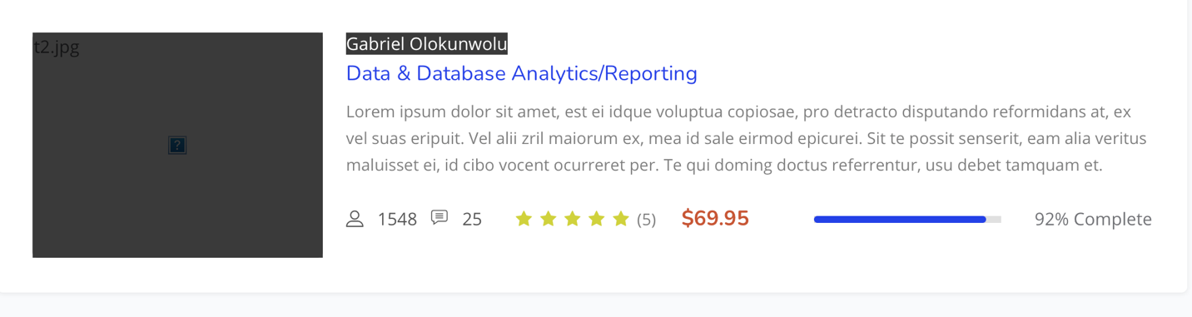

* Top of User profile page has a lot of space

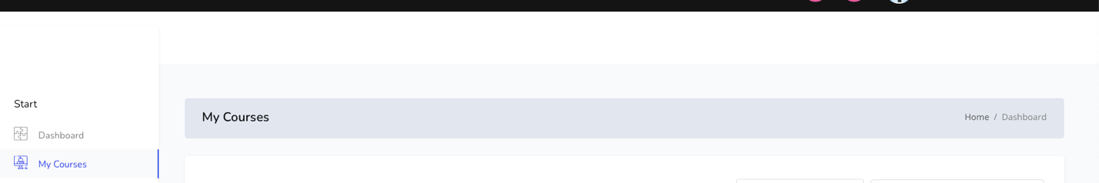

* Footer is too high/large (Black portion below)
* Add a 3rd section to include User Account balance/ payment plan, installment and due dates

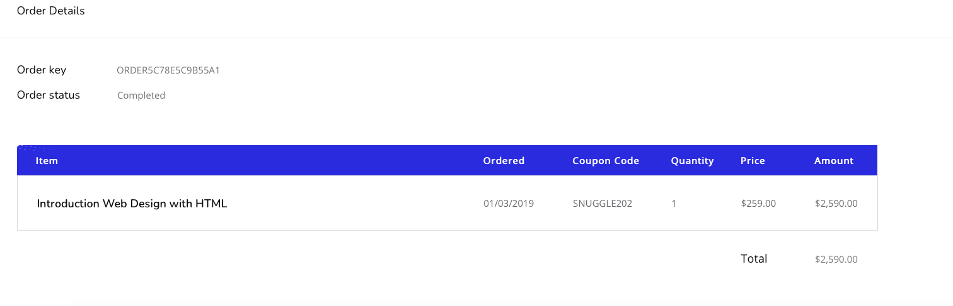

* Students profile landing page should include

Blog posts and the link to their blog posts

Option to delete a blog post

Option to add new post

Option to edit